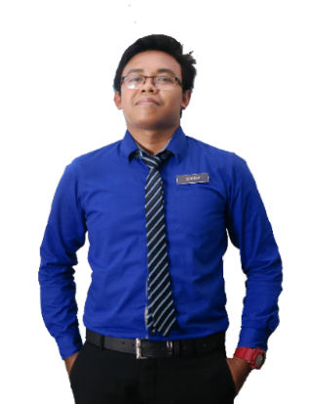

**RAFIRAH TAN SRI MOHAMAD ARIFF**

Manager

Suruhanjaya Sekuriti Malaysia No.3

Persiaran Bukit Kiara, Bukit Kiara

50490 Kuala Lumpur.

Phone: +6012-2802542

**PARMA CHANDRAVEVAH**

Advocate & Solicitor

51-4 (3rd Floor), Jalan SP 2/1

Taman Serdang Perdana Sek 2,

Sek 2, 43300 Seri Kembangan.

Phone: 03-89596335

Email: [parmaschamber@gmail.com](mailto:parmaschamber@gmail.com)

Sept 2019 - Present

**REFERENCES**

* Kuala Lumpur Southeast Asian Games Volunteers 2017
* Hockey Team Under 18 Years Old

**ACHIEVEMENT**

Aug 2010 - Jan 2012

Assistant Admin Officer

**PERBADANAN TABUNG PENDIDIKAN TINGGI NASIONAL (PTPTN)**

**SURUHANJAYA PENGANGKUTAN AWAM DARAT**

Clerk

Apr 2012 - Nov 2014

Feb 2015 - Feb 2017

**LEMBAGA PERINDUSTRIAN KAYU MALAYSIA**

Assistant Admin Officer

**PERBADANAN PERPUSTAKAAN NEGERI SELANGOR**

Admin Assistant (Part-time)

July 2017 - Nov 2017

**MALINI AND SHOBA ADVOCATES & SOLICITORS**

Clerk

May 2018 - Nov 2018

**SURUHANJAYA SEKURITI**

Clerk

Dec 2018 - Aug 2019

**WANG KUO SHING & CO**

Clerk

**WORK EXPERIENCE**

2005

2006

2010

**POLITEKNIK SULTAN SALAHUDDIN ABDUL AZIZ SHAH**

**SEKOLAH MEN KEB BANDAR BARU SENTUL**

Sijil Pelajaran Malaysia (SPM)

**GIATMARA SEGAMBUT**

Malaysian Skill Certificate Level 2 (Computer System Technician Assistant)

Diploma in Business Studies (Management)

**EDUCATION**

Flexible, willing to learn new things, fast learner, dedicated, able to work under less supervision and under pressure situation. Hard working to complete task given and multitasking.

**ABOUT ME**

**IC No:** 123456-07-5467

**Date of Birth:** 20 October 1988

**Marital Status:** Single

**Gender:** Male

**Race:** Malay

**PERSONAL DETAIL**

**CONTACT**

**ADDRESS**

B-38-13A PPA1M Bukit Jalil, 57000 Kuala Lumpur

resumecreative@yahoo.com

**E-MAIL**

**PHONE**

+6013-2805916

**Micro. Excel**

**Computer**

**Micro. PowerPoint**

**Micro. Word**

**SKILLS**

**Honesty**

**Hardworking**

**Responsible**

**STRENGTH**

**Communication**

**Team Work**

**Fast Learner**

**+**

**+**

**+**

**AHMAD FADHLI BIN LIMAT**

**AHMAD FADHLI**